**Software Requirements Specification for "Quizify"**

## **1. Introduction can**

**1.1 Purpose**

The purpose of this document is to detail the requirements for the development of "Quizify," an online quiz game. It serves as a comprehensive guide for the project team and stakeholders.

## 

**1.2 Scope**

"Quizify" aims to create an interactive platform where users can engage in quizzes across various subjects, fostering competition, knowledge sharing, and a sense of community.

## 

## **2. Overall Description**

**2.1 Product Perspective**

"Quizify" will be a standalone web application utilizing a microservices architecture for scalability and a progressive web app (PWA) approach for a responsive user interface.

**2.2 Product Features**

User registration and authentication

Quiz creation and management

Randomized questions for quizzes

Scoring and leaderboards

Social interaction features (e.g., comments, likes)

Admin panel for content moderation

**2.3 User Classes and Characteristics**

Registered Users: Individuals who create quizzes and participate in others.

Admin Users: Responsible for content moderation and platform management.

## **3. Specific Requirements**

**3.1 External Interfaces**

User Interface: Intuitive and user-friendly design.

APIs: Utilize APIs for user authentication and potential future integrations.

**3.2 Functional Requirements**

Users can register, log in, and manage their profiles.

Users can create quizzes, specifying subjects and questions.

Quizzes feature randomized questions for each attempt.

Scoring and leaderboard functionality based on quiz performance.

Social interaction features such as comments and likes on quizzes.

**3.3 Non-functional Requirements**

Performance: Response times should be within acceptable limits even as user and quiz numbers increase.

Security: Implement secure authentication and protect against common web vulnerabilities.

Scalability: Design the system to handle an increasing number of users and quizzes.

## **4. Constraints**

Development will be carried out by a team of four students.

Limited initial financial resources.

## **5. Assumptions and Dependencies**

Assumes a stable internet connection for users.

Dependent on the availability and reliability of external APIs for certain features.

## **6. Use Case Diagram**

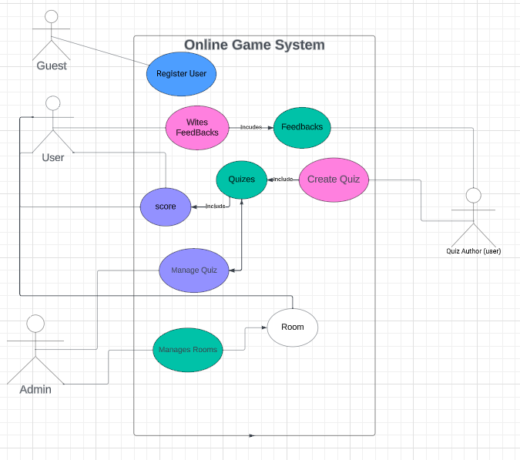

## 

## **7. Context Diagram**

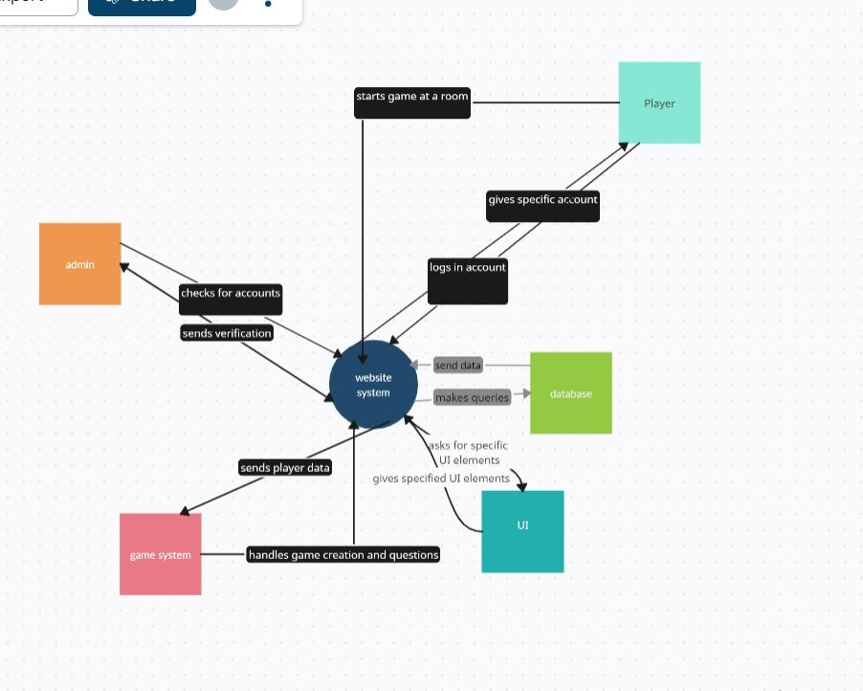

## **8. Concept Diagram**

## 

## 

## 

## **9. Class Diagram**

## 

## **10.Sample UI**

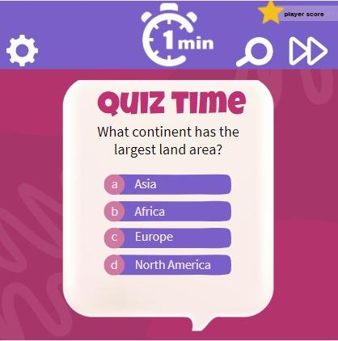

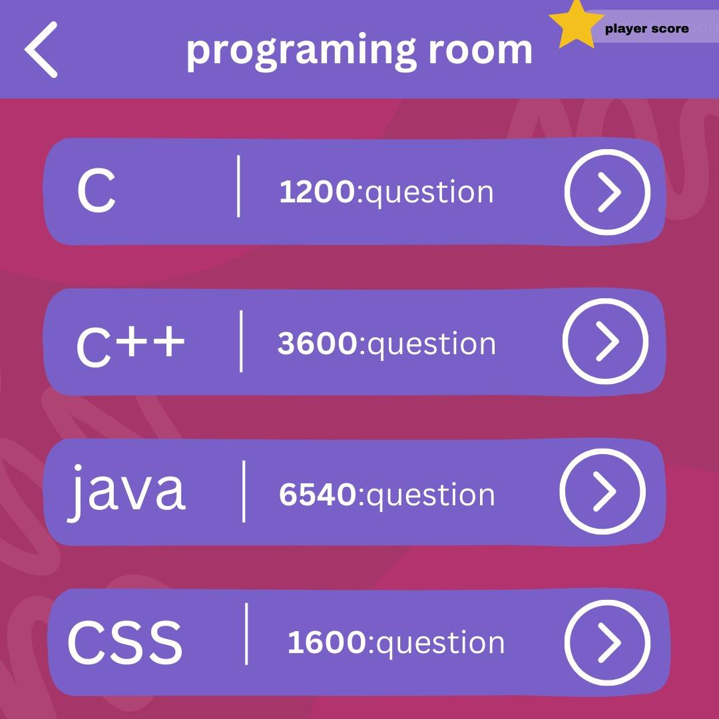

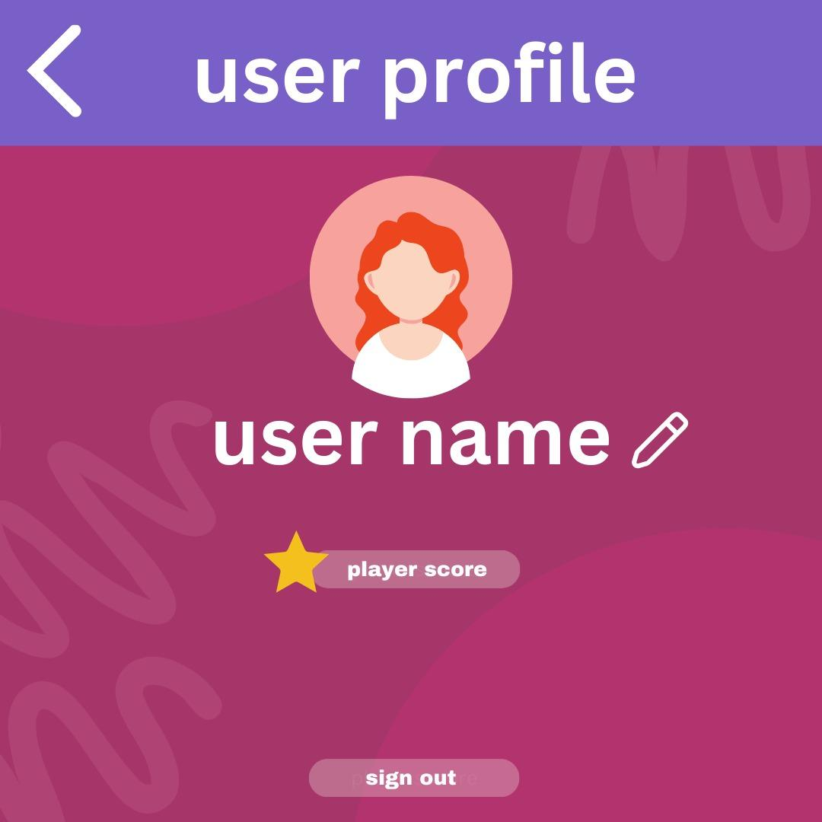

## **11. GitHub Repository**

The source code for the "Quizify" project can be found on the GitHub repository at the following URL:

[budi641/Quizify (github.com)](https://github.com/budi641/Quizify)